

**CSS Properties**

1. **Selectors: Class Selectors**

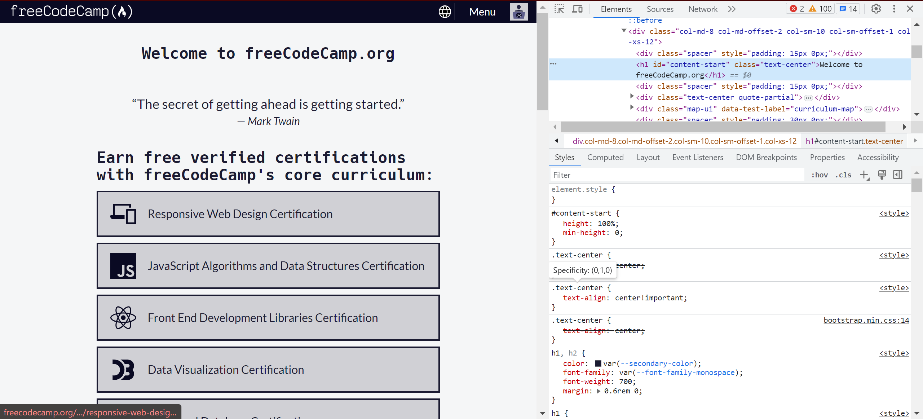

1. **Properties and values:**

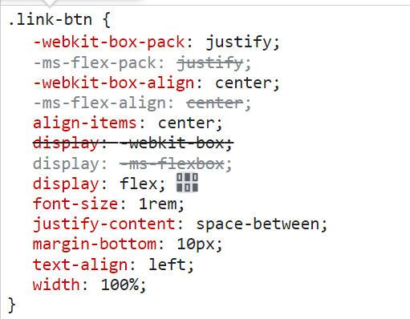

1. **Declaration Blocks**

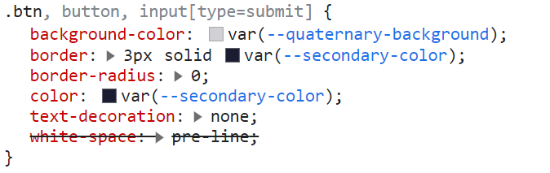

1. **External , Internal and Inline CSS**

**Inline** - 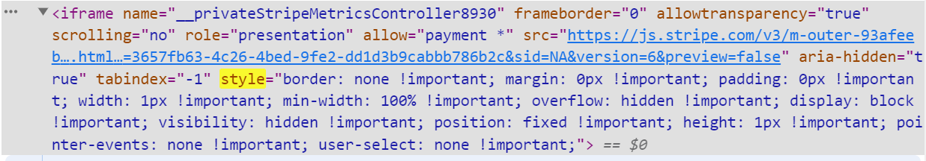

**Internal** - 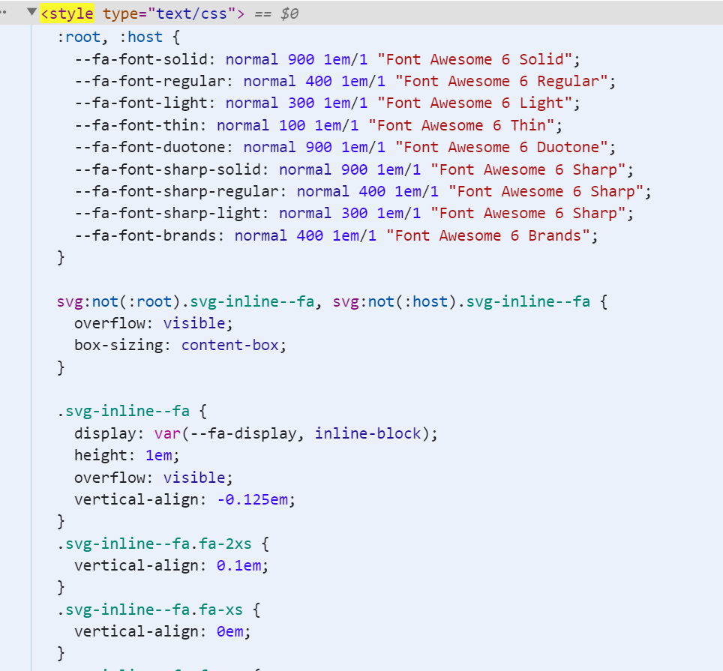

**External** -

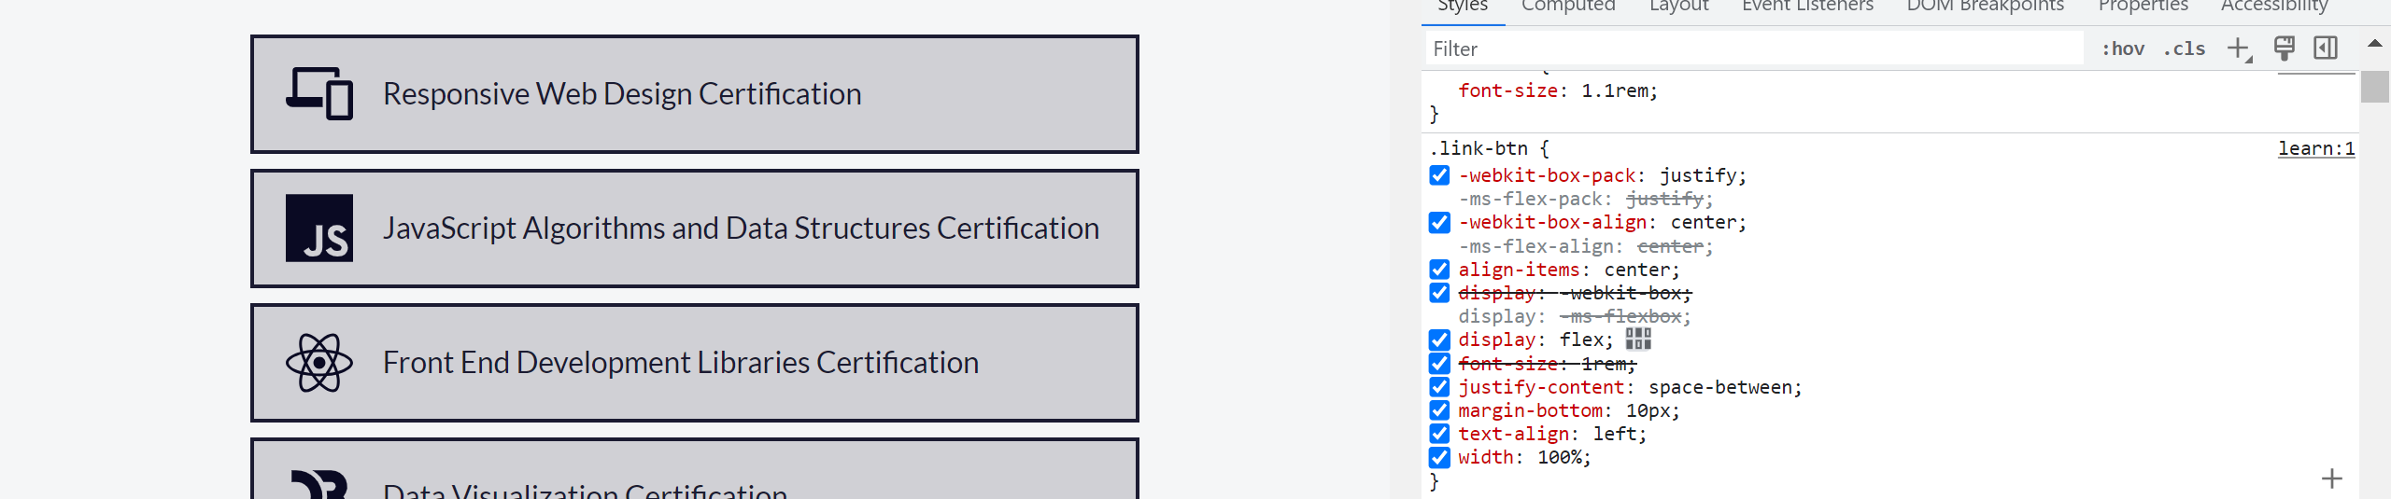

**Cascading and Specificity:**

**Cascading**

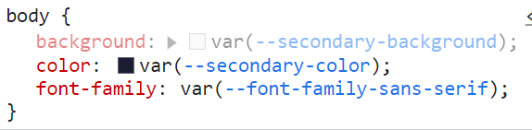

**Specificity** - 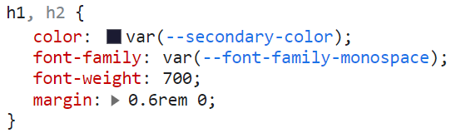

**Box Model:**

**Padding**

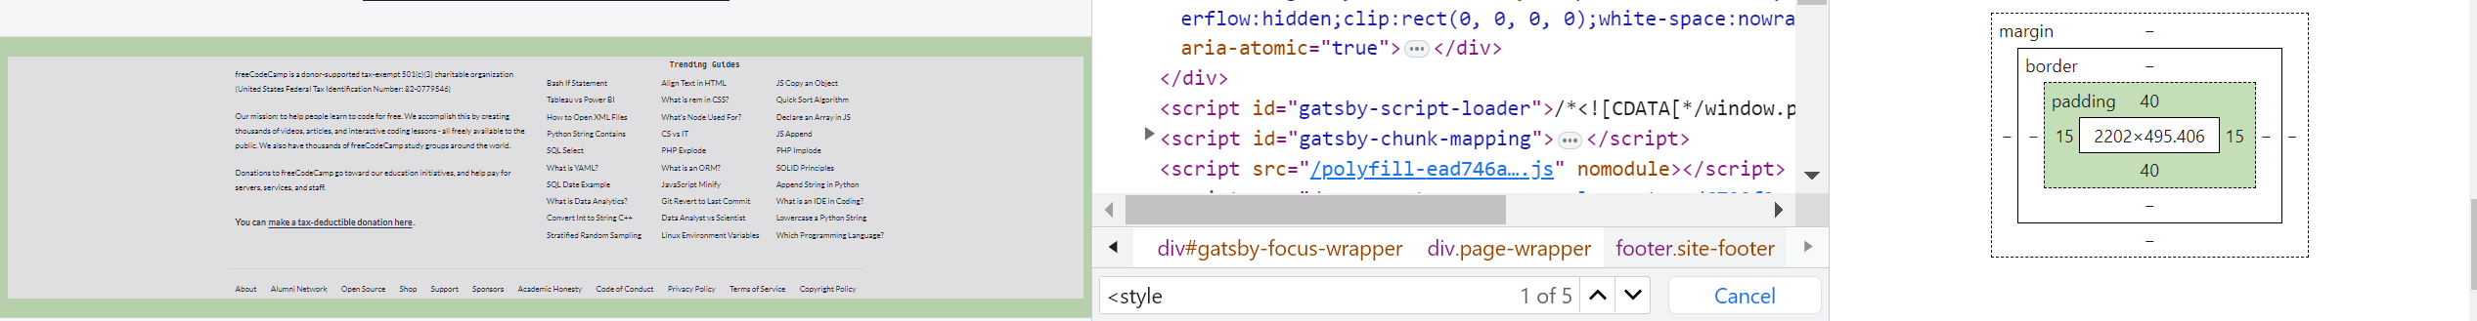

**Content** -

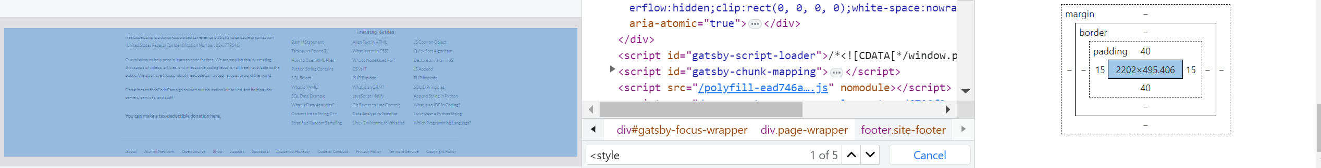

**Units of Measurement :**

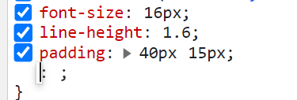

**Colors:**

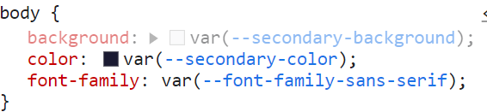

**Fonts** -



**Transitions and animations:**

**Hover**:

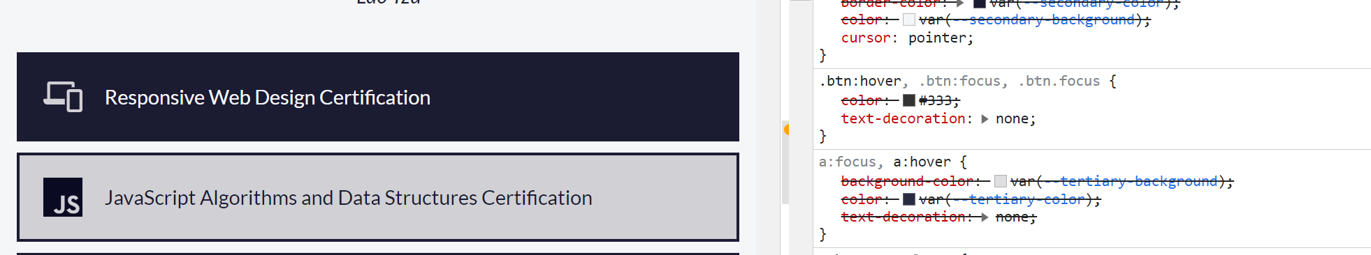

**Pseudo Elements:**

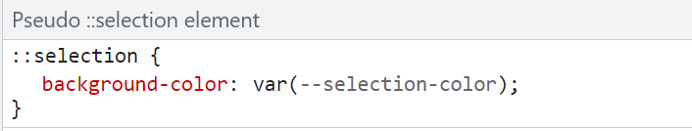

**CSS Preprocessors:**



**Vendor Prefixes :**

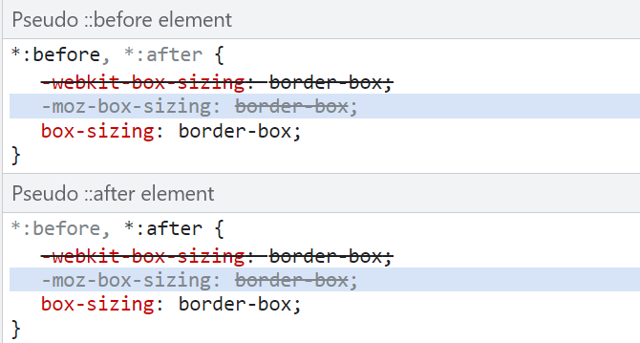

**Layout Technique:**

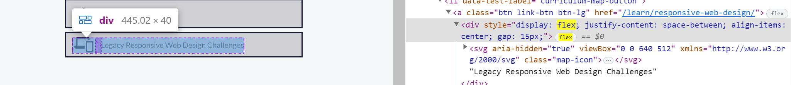

**Responsive Design :**

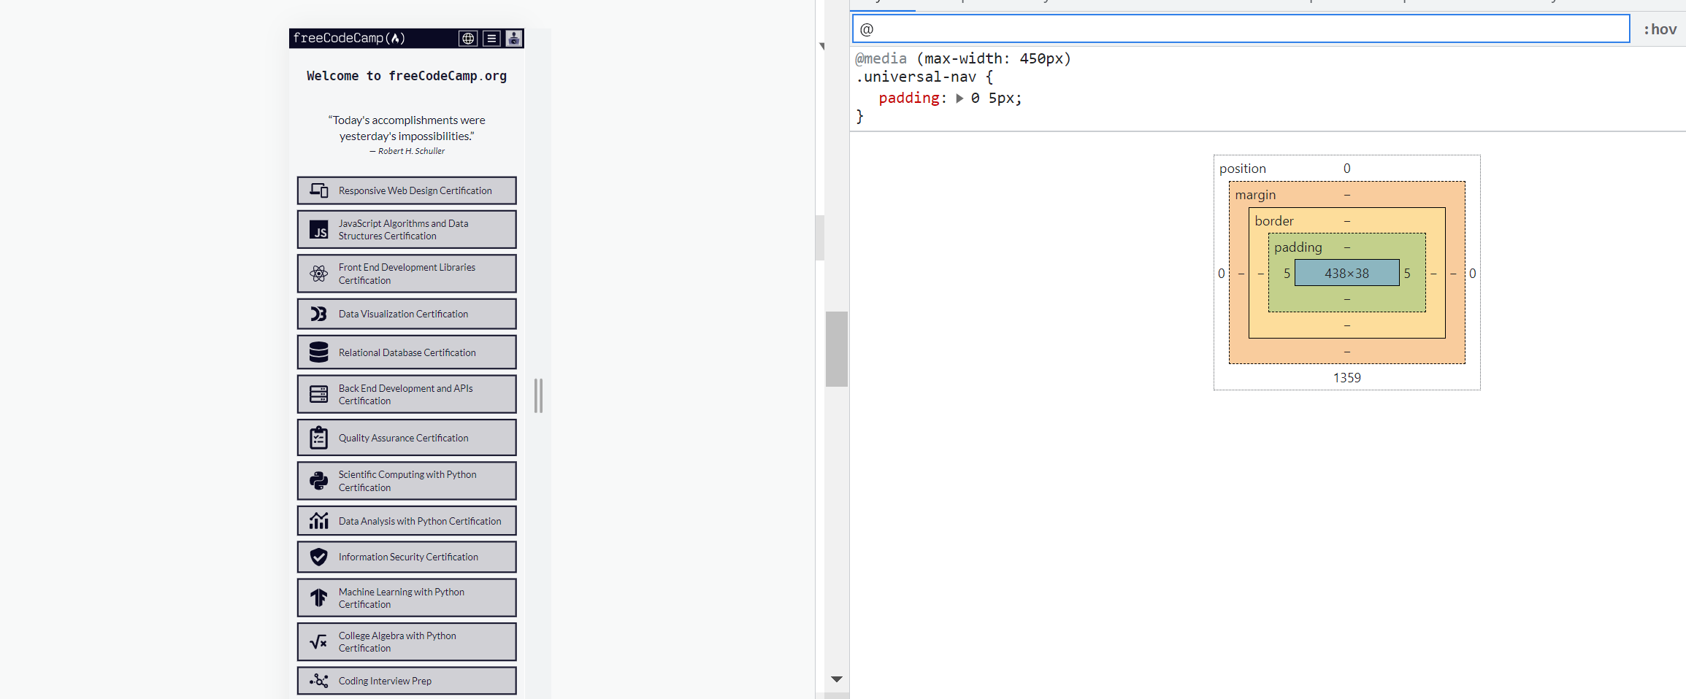

**Inheritance:**

